Deployment Manual

* Download the compressed project from the given GitHub link: Link: https: [bsnehalkumar/LibraryManagementSystem (github.com)](https://github.com/bsnehalkumar/LibraryManagementSystem)
* Open STS and import the downloaded file.
* Go to your application properties and change the credentials according to your system.
* The port number we have given is 9096, if this port is busy, change the port number.
* Run the project as spring boot application as shown in the picture below.

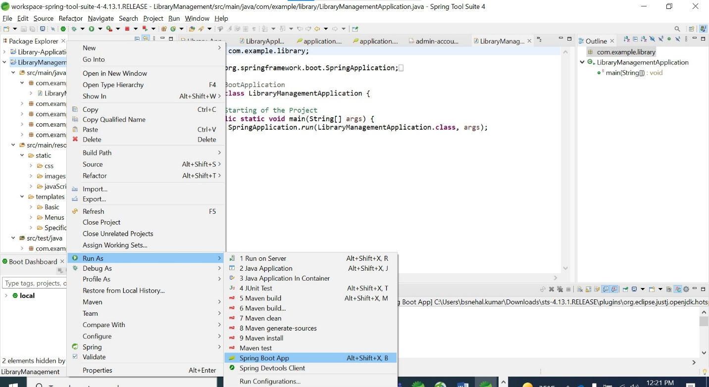

* Once, it shows login registration application has started in the console, open up your web browser and type localhost:9096/ (or localhost: port number/).

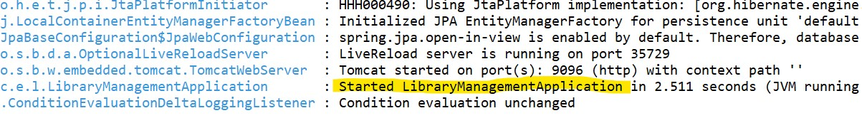



* ***Once it gets loaded, main page of the site gets opened up.***



* ***To login to admin account, click login in the navigation bar.***

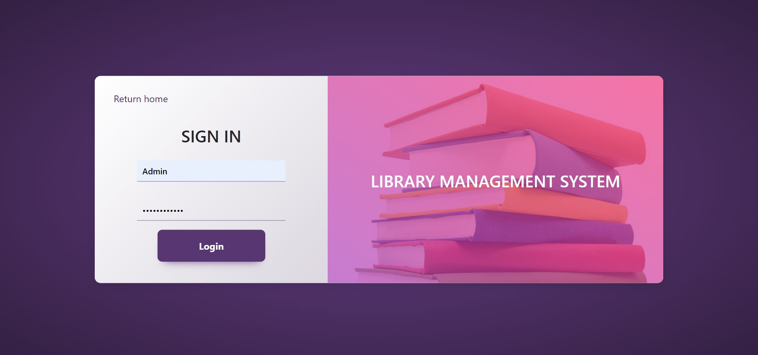

* ***Now the dashboard opens.***

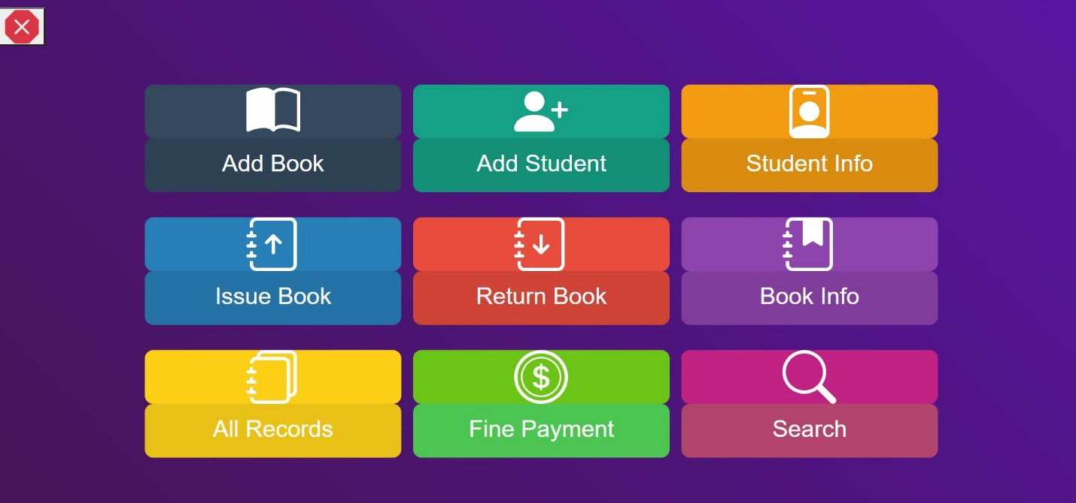

* ***Add book***

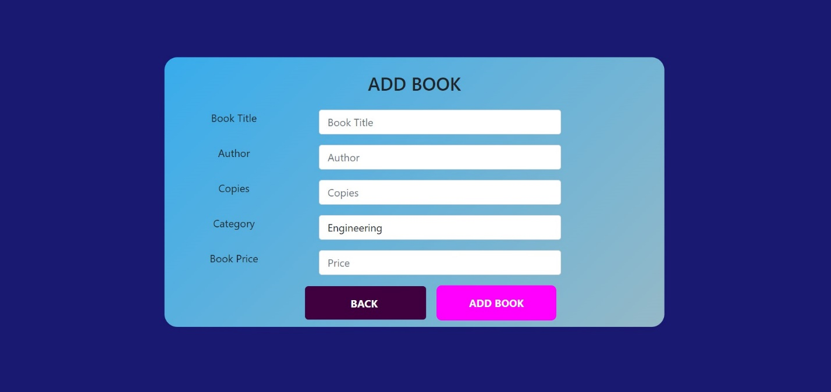

* ***Add student***

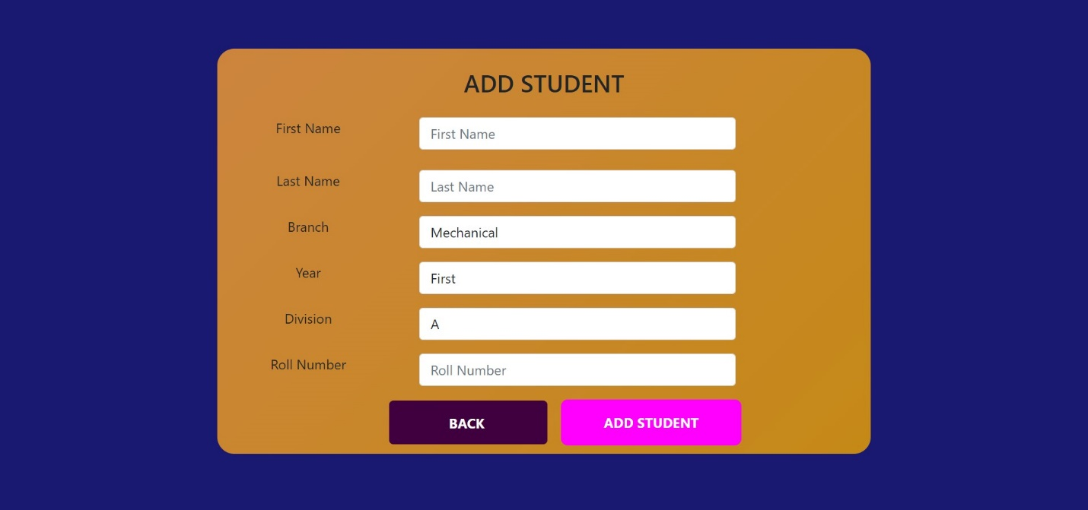

* ***Student Info***

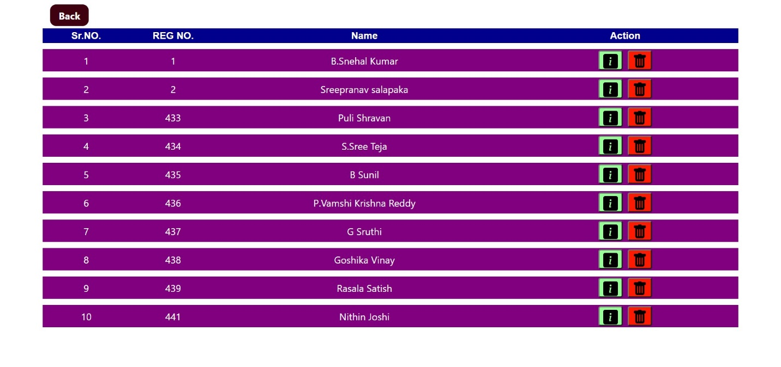

* ***Issue Book***

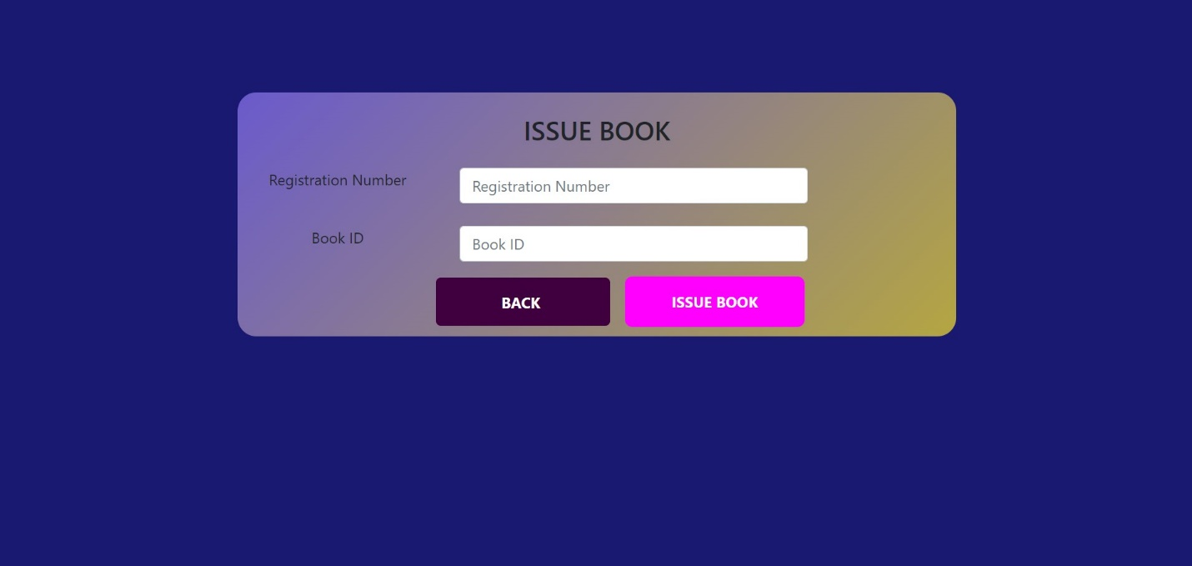

* ***Return Book***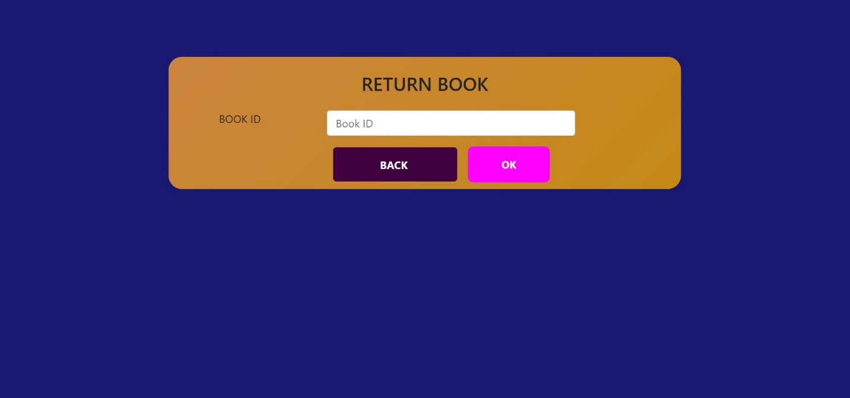
* ***Book Info***
* ***All Records***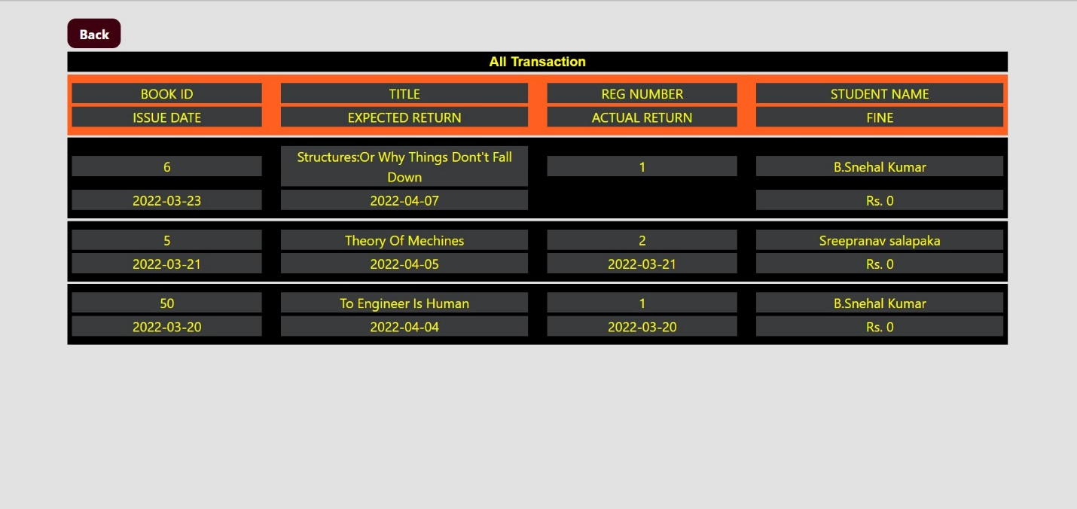
* ***Fine payement***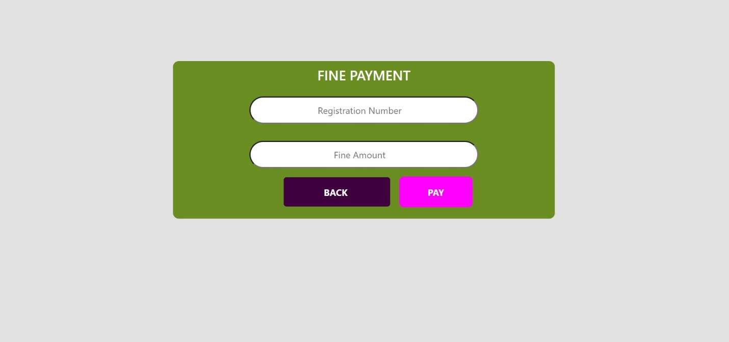
* ***Search***